**CICD EXPERIMENT – 6**

**Create Pipeline using Jenkinsfile**

1. Go to Jenkins dashboard and select New Item option
2. Enter the item name and choose Maven project
3. Now go to Pipeline tab and write a definition regarding the command and enter the URL of the github repositor

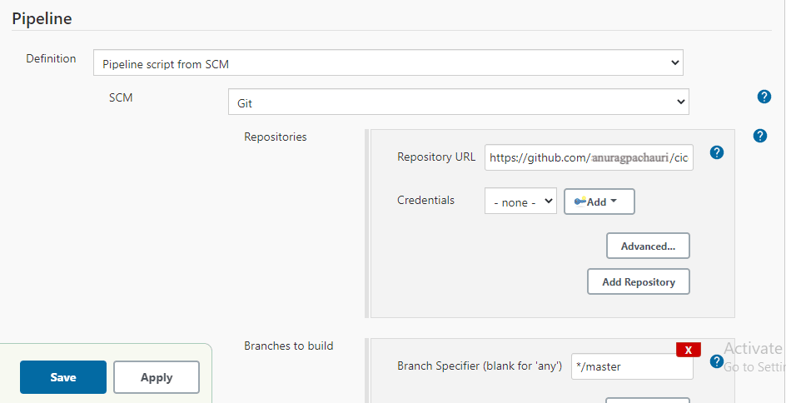

1. Now go to the github repository whose address is copied and create a “Jenkinsfile”(if not already created) that tells the Jenkins server what tasks to perform. In this example, it asks Jenkins server to run 3 commands in 3 stages:
2. Echo “build stage”
3. Echo “test stage”
4. Echo “deploy stage”

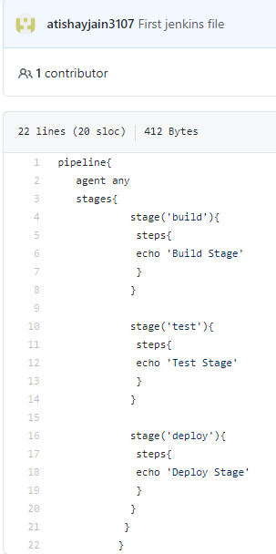

1. Now select build now option available on Jenkins dashboard and after successfully building, a pipeline will be created

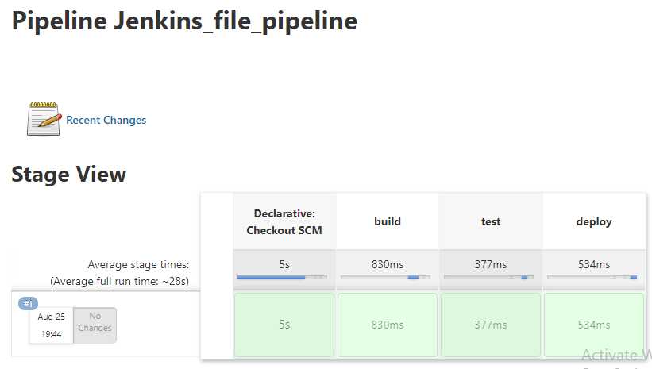

ANURAG PACHAURI

500069505

R171218026